**Molecular Epidemiology Pipeline (Mac/Linux) – Bahl Lab**

**For help contact:** Lambodhar –Bahl Lab PhD Student – ld26524@uga.edu

**Programs Required:**

BBEdit - <https://www.barebones.com/products/bbedit/>

Seqotron (Mac/ Linux) - <https://github.com/4ment/seqotron>

MAFFT – Command line tool - <https://mafft.cbrc.jp/alignment/software/macosx.html>

RAxML – Command line tool - <https://cme.h-its.org/exelixis/web/software/raxml/hands_on.html>

RAxML GUI - <https://sourceforge.net/projects/raxmlgui/>

Tracer - <https://beast.community/tracer>

BEAST v1.10 suite - <https://beast.community/>

PDA (Phylogenetic Diversity Analyzer) - <http://www.cibiv.at/software/pda/web-pda/>

TempEst - <https://beast.community/tempest>

FigTree - <http://tree.bio.ed.ac.uk/software/figtree/>

Flu databases:

GISAID - <https://www.gisaid.org/>

NCBI - <https://www.ncbi.nlm.nih.gov/genomes/FLU/Database/nph-select.cgi>

IRD - <https://www.fludb.org/brc/home.spg?decorator=influenza>

Command line tutorial:

<https://www.codecademy.com/learn/learn-the-command-line>

*For PC users, many of the steps are similar and can be done through the GUI that are provided for each of the programs. Command line program examples are shown for macOS, for PC use command prompt. For alignments viewing and editing, a program to use for PC users instead of Seqotron is called BioEdit (<http://www.mbio.ncsu.edu/BioEdit/bioedit.html)>

**Data collection/management**

Proper data management and organization is key in creating relevant datasets for the investigation of viral evolution. The dataset that is used in this tutorial is comprised of sequence data for seasonal H3N2 in Asia in the year 2017. This data was collected from GISAID. This dataset has ~2500 sequences, because of the size of the dataset it is important to sample down to give us a dataset that is easier to work with and that will not demand heavy computing power. Here we will detail two different methods of subsampling: random sampling and phylogenetic sampling. We will aim to subsample to 250 sequences.

**In the tutorial below we are keeping at least 30% of the sequences from Taiwan, due to the relevance to workshop audience, this will also be a good example of how to include important data that might be important to analysis while subsampling down the larger dataset. **

When collecting data for phylogenic analysis most databases will provide sequence data and associated metadata. Most metadata will be kept in a form similar to what is seen below:

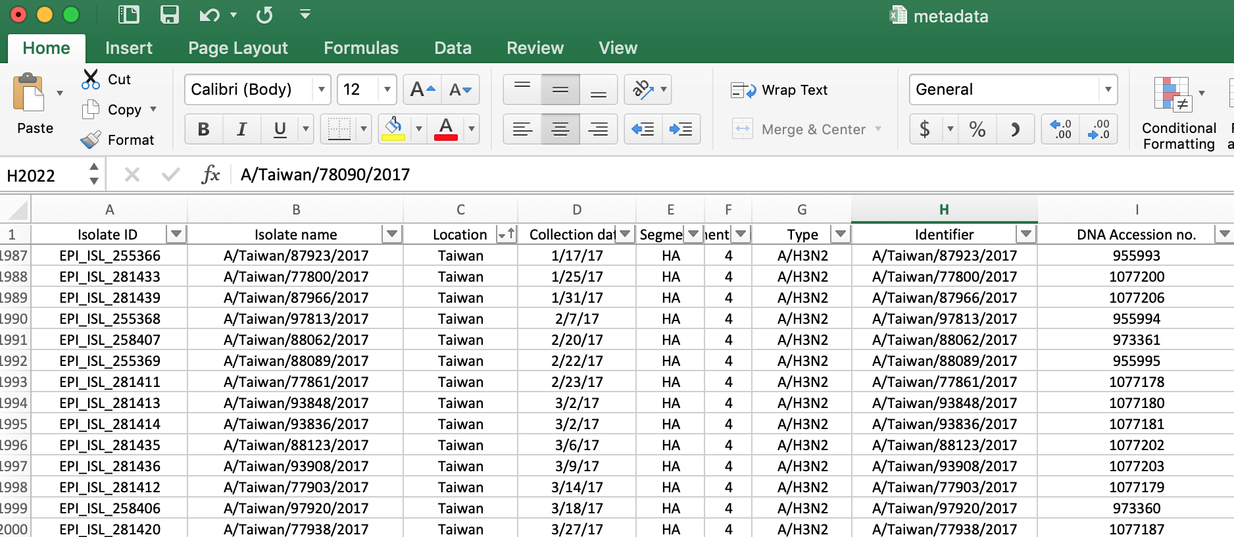

It is important to include sequence data with this metadata for further manipulation and proper labeling. (See next section for fasta file prep)

To manipulate a fasta file, the sequence data should be converted into tab format in order to insert into the spread sheet with metadata, this can be done by using regex, for simplicity this webpage can do the conversion for you:

<http://sequenceconversion.bugaco.com/converter/biology/sequences/fasta_to_tab.php>

Original fasta format:

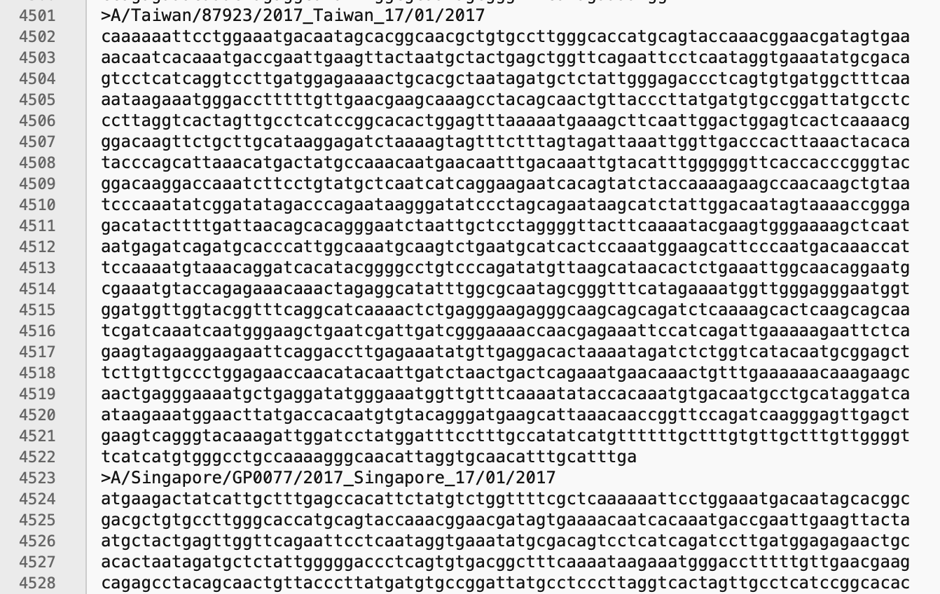

Once your fasta file is converted it will be in tab format seen here in BBEdit:

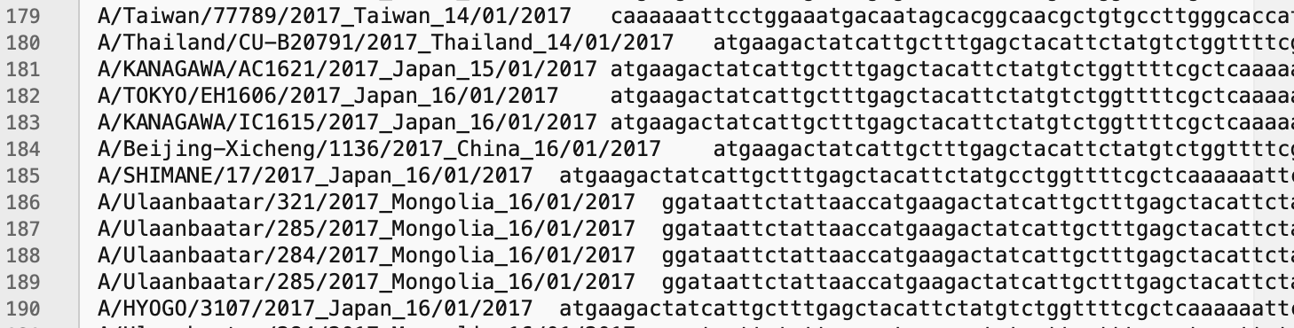

Open a new sheet in excel. Label the first two cells Label and Sequence. Open .tab file in BBEdit. Select all the data in the tab file and copy and paste directly into new excel sheet. Filter by label alphabetically. The filter option is available in the Data tab of excel.

Pasted data in new sheet: Filtered alphabetically by label:

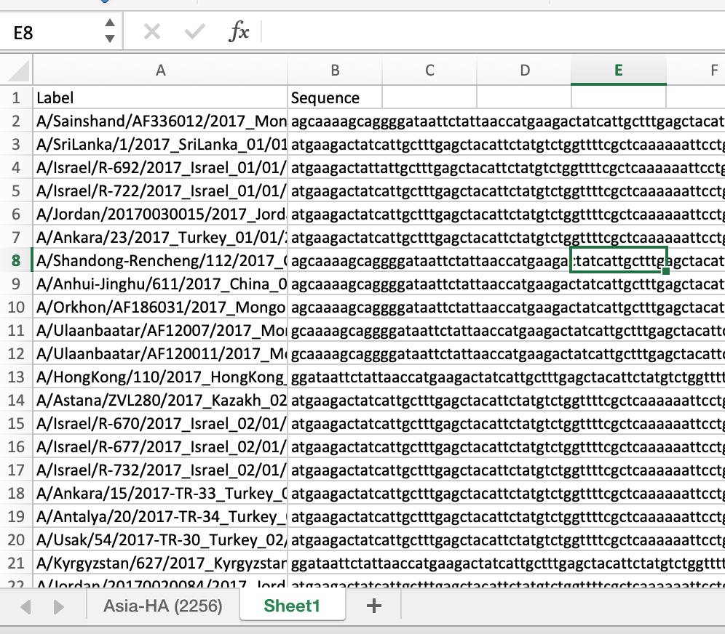 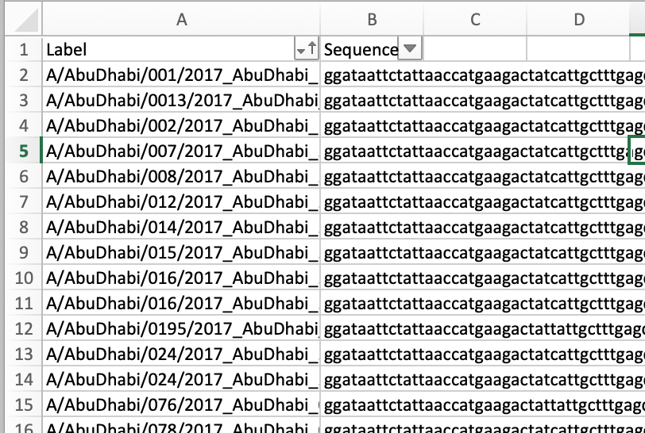

In the first sheet of the excel file filter data by Isolate name (when filtering ensure that you filter by the same identifier as your sequence data, typically this is an accession number/sequence ID)

Copy and paste this into the first sheet in containing metadata in the two empty columns left of the metadata. Filter and check that sequence data accessions/labels match the accessions/labels in your metadata file.

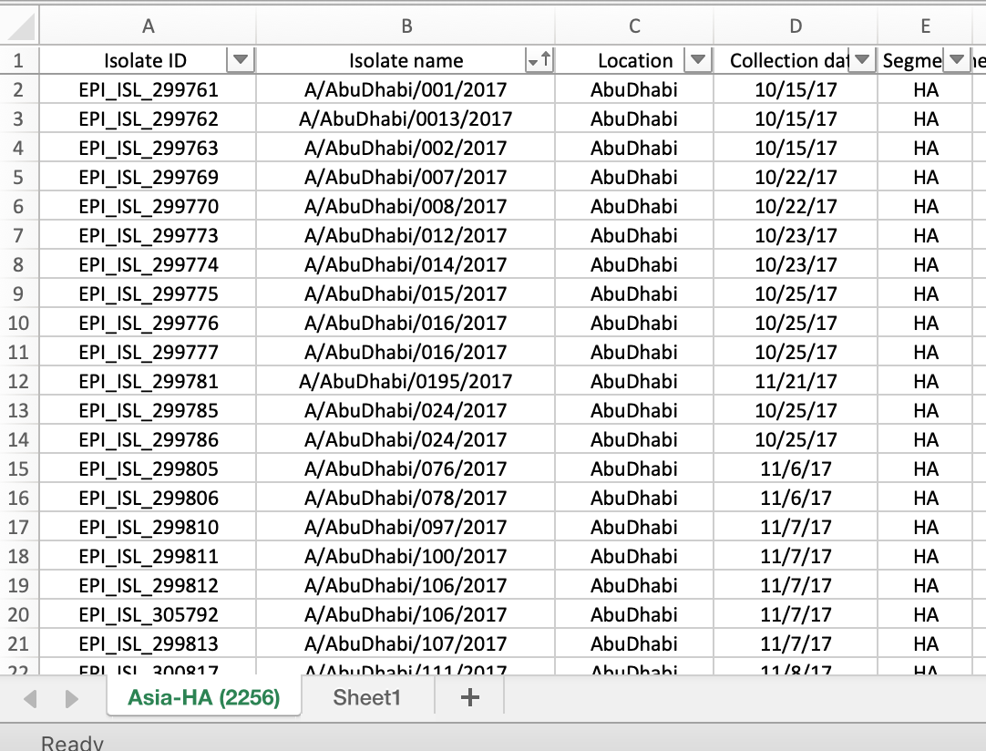

Copy and paste this into the first sheet in containing metadata in the two empty columns left of the metadata. Filter and check that sequence data accessions/labels match the accessions/labels in your metadata file.

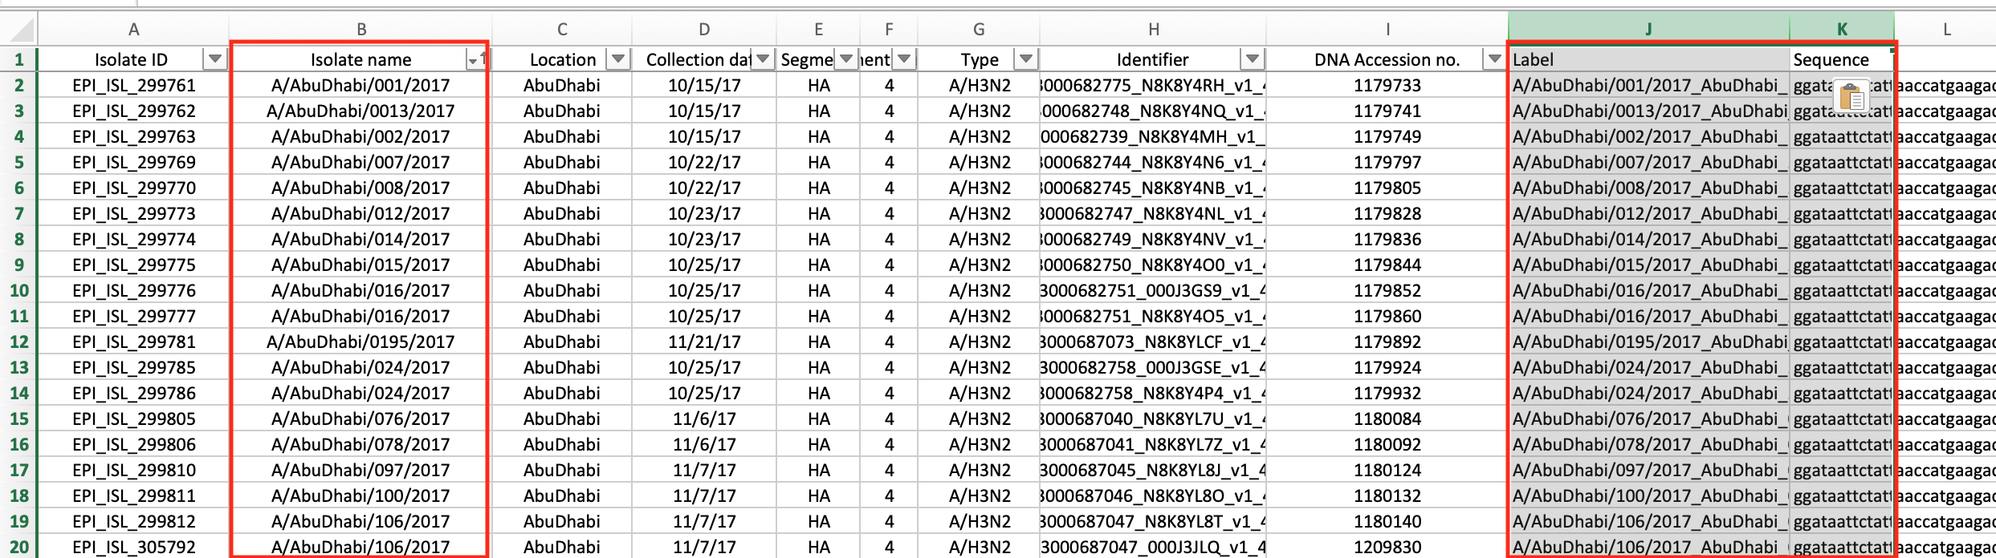

This sheet now includes both metadata and sequence data organized together by each sample. We will now use this sheet to randomly sample down our data and remove unwanted/erroneous data.

We should first identify records that do not reflect our desired dataset, in this case any samples that are not from Asia, the correct organism/virus, correct date, etc. An example of a sequence in this dataset that is unwanted is seen below, look for this record and other similar ones and remove by highlighting the row and deleting the sequence:

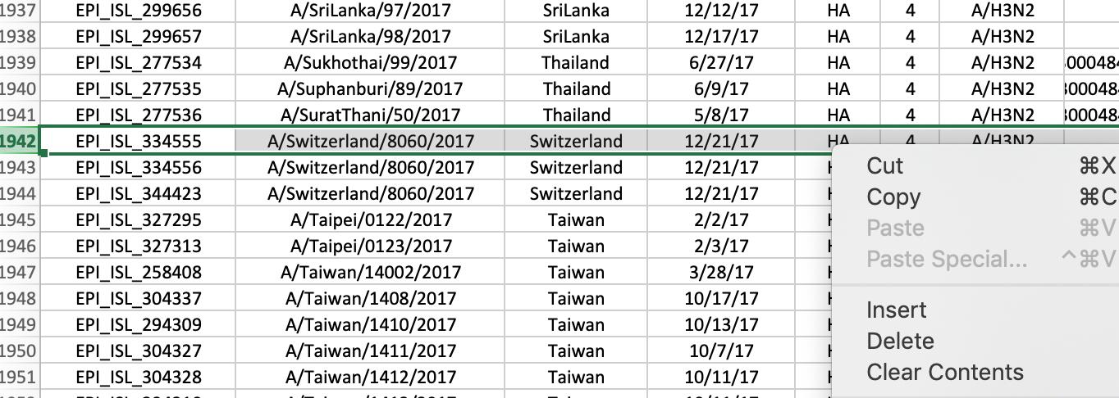

The next step is to remove any data that we are not going to use in our phylogenetic analyses. Remove data columns for data that is not desired and reorganize data as desired (this will be important for creating sequence labels).

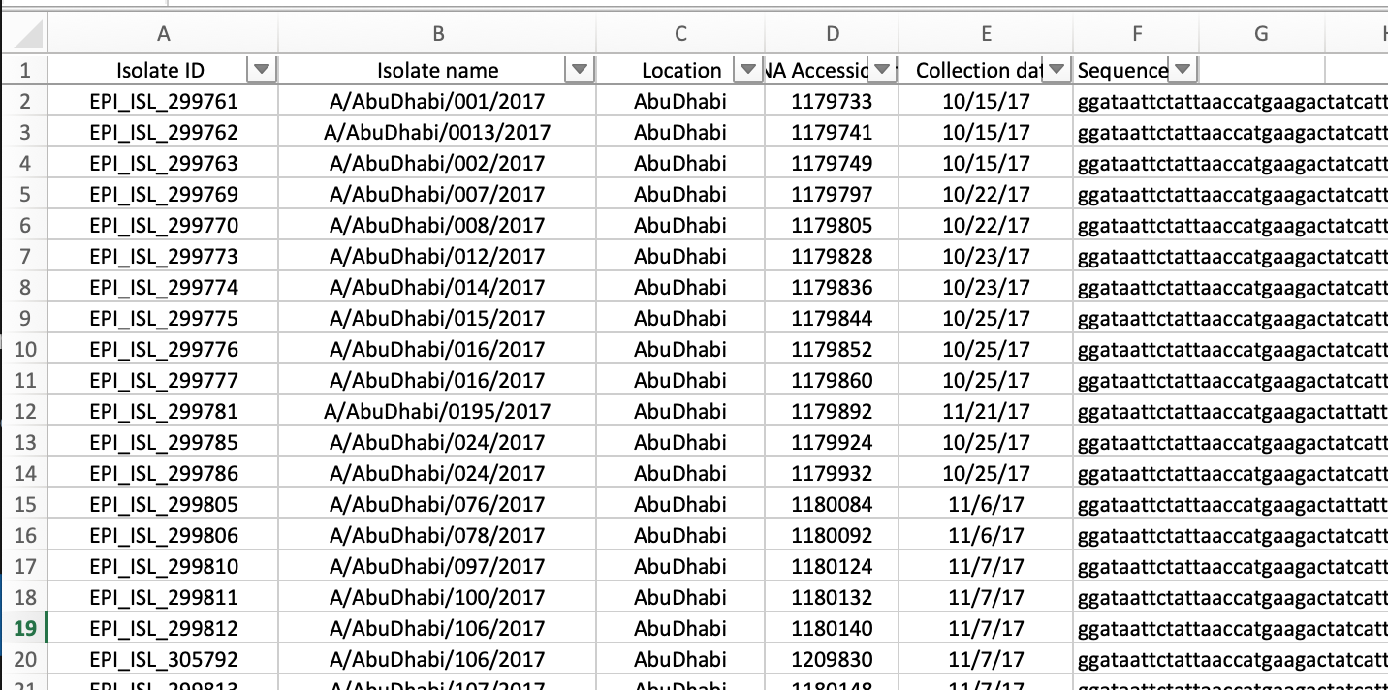

For this analysis, we are planning to use a subset of 250 sequences. Because we intend to retain 30% of the sequences from Taiwan we will first extract the sequences from Taiwan from our metadata sheet (filter by country and copy all rows from Taiwan). Cut and paste them into a new datasheet with proper labels in the first column.

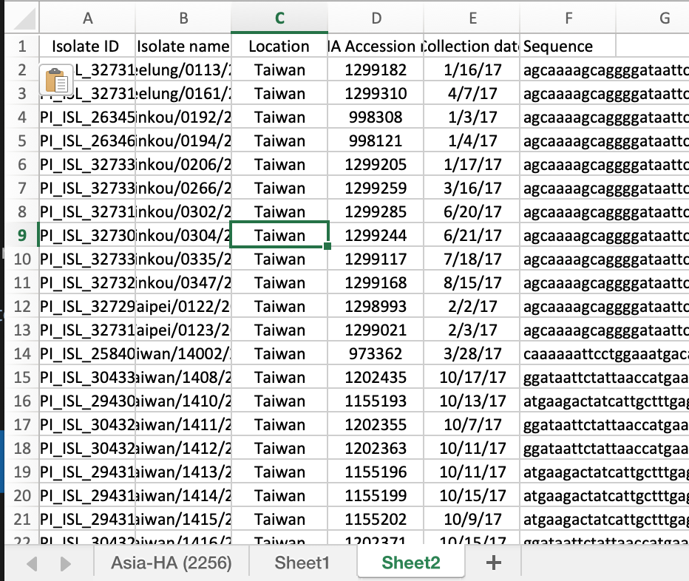

In order to randomly select sequences from this list first insert a column and label this as “rand”. Using the following excel function “=RAND()” generate random numbers in the “rand” column. Copy the column and then paste in same cell, use the option of “Values only” to retain only values from RAND() generation. We will then filter by the “rand” column. Because we desire 30% of the sequences in this list we will retain the first 47 sequences of this dataset.

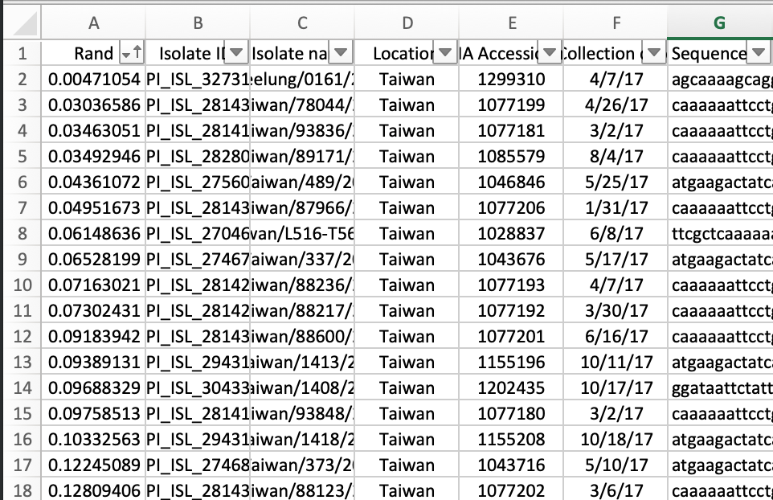

Copy these sequences into a new excel sheet, this sheet will be the final dataset where the rest of the sequences will be added. Repeat the process above in the main metadata (with Taiwan sequence removed to prevent duplicate records). When the sequences are filtered by random values, copy the first 203 (because we are including 47 isolates form Taiwan) and paste them into the final datasheet.

This is the final dataset that will be used to create fasta files with proper labels (See next section). Another method of subsampling is stratified sampling based on the number of records from a given place and date. This can be done by visualizing the data and deciding an appropriate way to subsample for each desired country/date. This can be done using Tableau (<https://www.tableau.com/)> or using R programming in R studio (<https://www.rstudio.com/>).

**Fasta file prep**

The first step in trying to do phylodynamic work is combining the sequence data with the metadata about the sequence. We do this by including key information about the sequence within the sequence label in a systematic way in order to organize and visualize our data for further analysis when we build our phylogenetic trees. This data is seen in the *FASTA* format below:

>SEQUENCEID |type | strain | Host | Place | Date

atcgatcgatcgatcagctagctagctagcatcgatcgactgactagcatgcatcgatga

>KM229177|A|H3N2|Human|TaiWan|2019/03/12

acctgatcatggatctcagatcatgactacgatggatcagcatgcatgcatcgatcgatcg

When working with sequence data and creating trees it is important to keep relevant metadata tied to the sequence in order to help make inferences about the overall evolutionary relationships between sequences. The bar ( | ) is used as a “delimiter” that simply organizes and separates the data for that sequence in the label, many different delimiters can be used ( . ; - + etc..) it is just important that the use of a delimiter is consistent. Programs in the BEAST suite take advantage of good sequence labels and can allow the user to parse information into their programs using the delimiters chosen.

There are many ways to effectively labeled your sequences, one way is to modify data in an excel file and use REGEX (regular expressions) to manipulate the text within a text editor (in this case we are using BBEdit). See steps below for how to process the data names of your fasta file. To manipulate our fasta in excel, columns must be added with a desired delimiter as well as the fasta sequence identifier (>) in the first column, and a random character to separate sequence labels from sequence data (here we will use &).

*Before delimiters:*

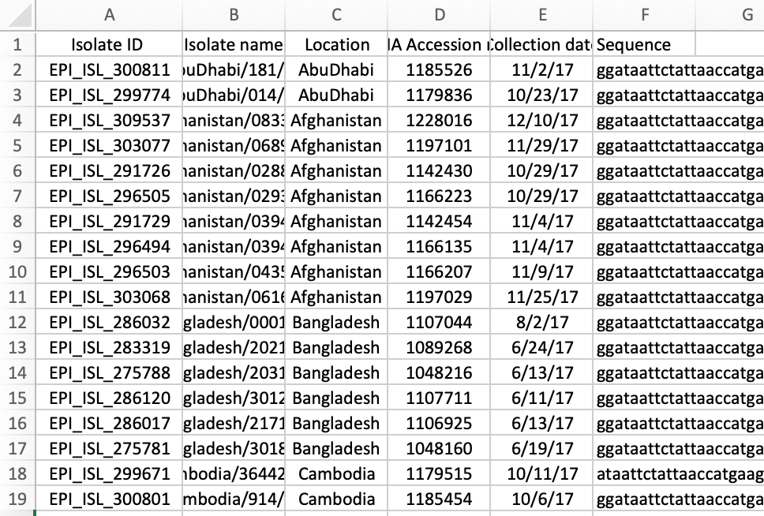

*After delimiters:*

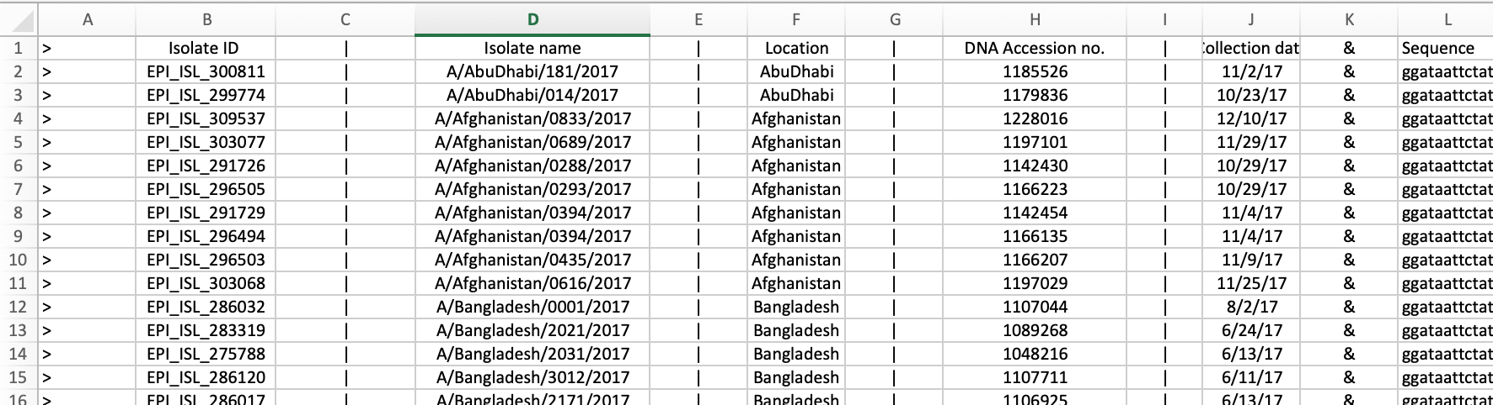

Once delimiter columns are added, copy and paste the sheet into BBEdit.

Using the following commands in images below, you can condense the sequence labels and create a properly labeled fasta file.

For this command use the “grep” function. (\t indicates a tab)

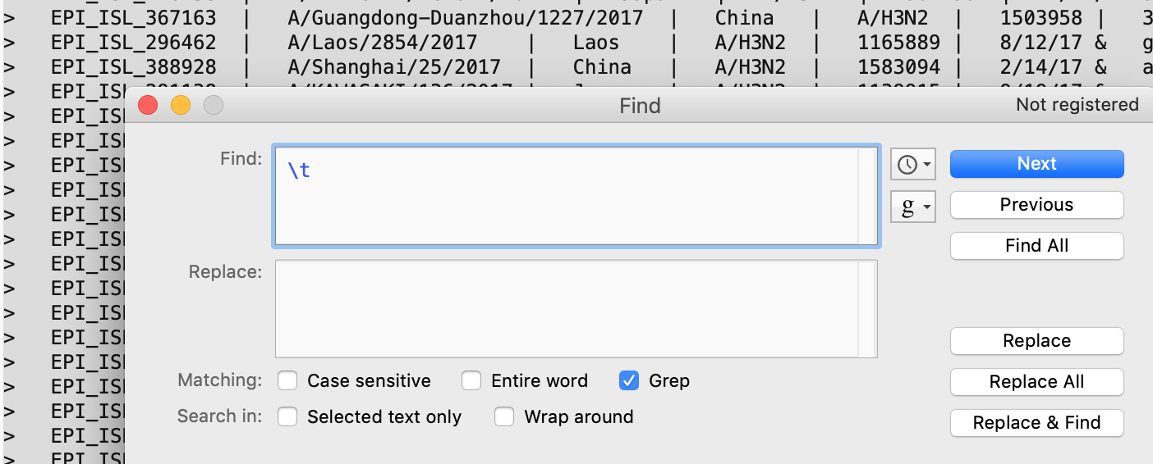

For this command, we are replacing our special character at the end of our metadata with a new line. (\n indicates new line character)

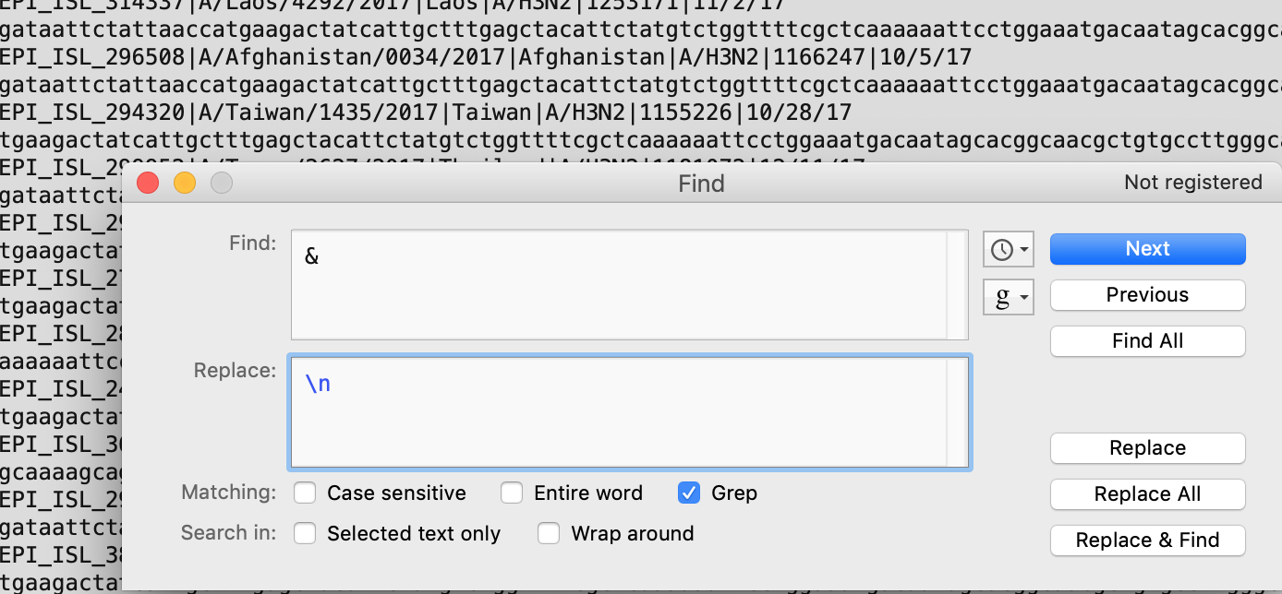

The final result should be a file with a record indicator “>” , sequence label, and a sequence on the next line. (**Remember to remove the first two lines**)

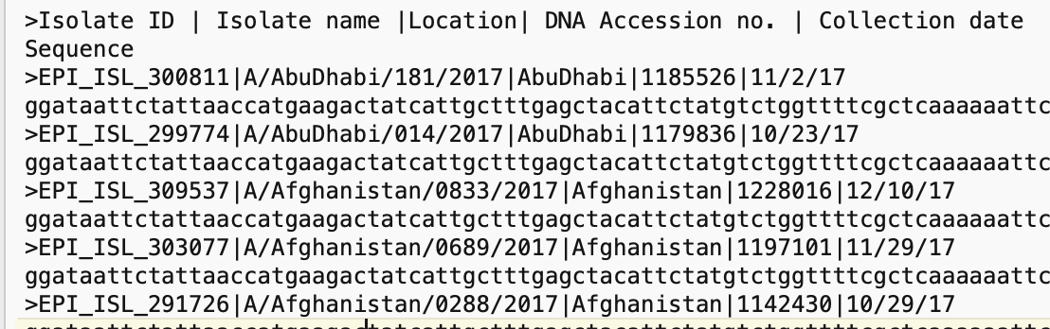

This file is now ready for use in the rest of our pipeline, we will rename the file to inform us what the data is: Asia2017H3N2_subset.fasta

The next step is sequence alignment and processing, this file will be used in the next example.

**Sequence Alignment**

1. Alignment file should be in FASTA format.
2. Use the following command in Terminal:

mafft input.fasta > output.mafftout.fasta

( .mafftout is added to the output name in order to keep track of alignments that have been done and distinguish from raw unaligned fasta files)

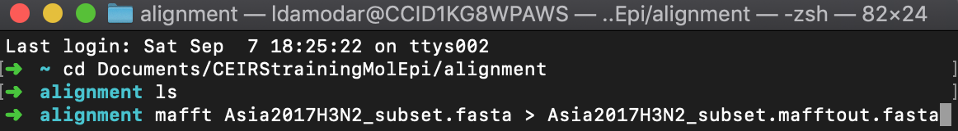

For PC users: Run the MAFFT program in command prompt and use the path of the alignment file as the input file. Specify your output file when prompted ( xxxxx.mafftout.fasta) and when prompted for desired file output choose option 3 (Fasta format). Next, when prompted for running scheme choose 1 (--auto). Press enter when prompted and program will run.

**Post-alignment Processing**

1. Open alignment file from MAFFT (output.mafftout.fasta) in Seqotron.

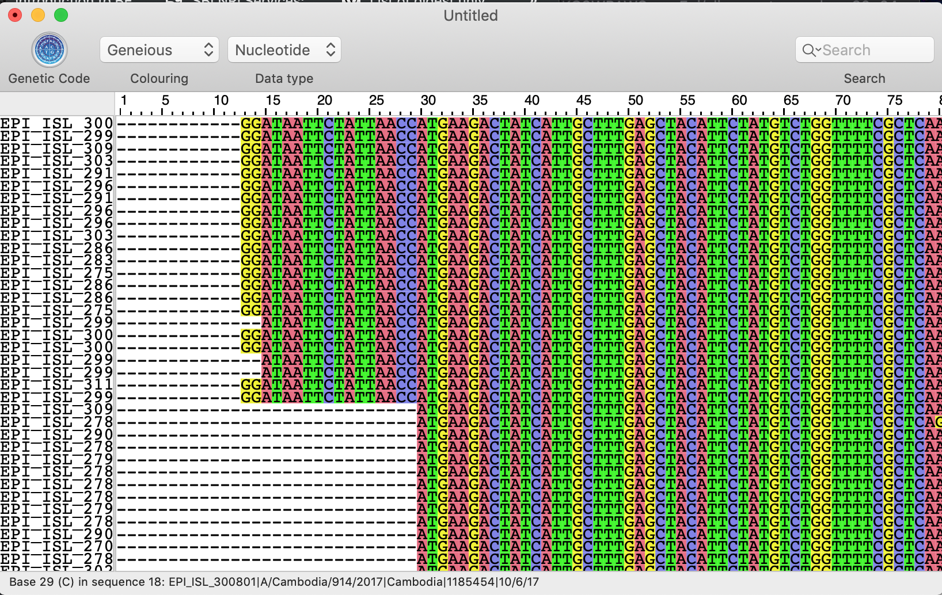

1. Examine alignment for gaps due to misaligned sequences (Example below)

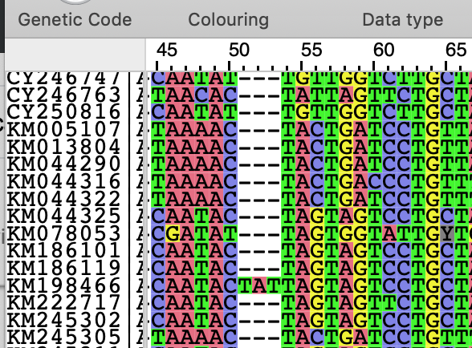

Sequences that create gaps should be removed in order to optimize alignment. It is important to record any sequences that are taken out.

1. Choose a reference sequence with a known start and stop codon. Identify start and stop codons in alignment, remove any nucleotides that are before start codon and after stop codon.

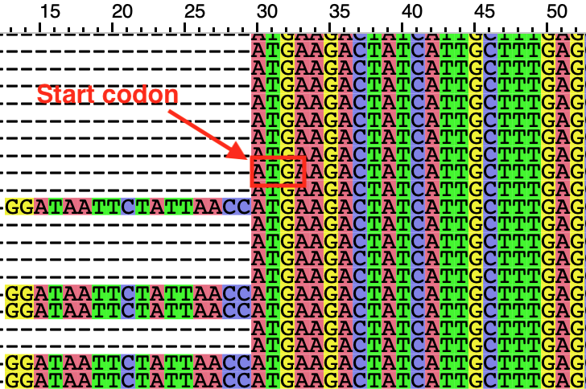 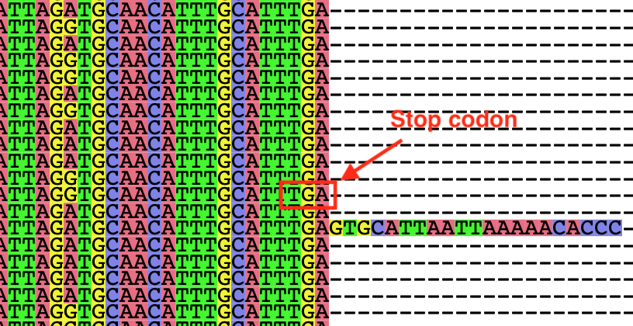

If sequences are missing a significant number of nucleotides after the expected region of a start codon or before expected region of stop codon (10% of expected gene length missing) these sequences can be removed.

1. When the gaps have been addressed, you can realign in order to close any gaps in the overall sequence data, or you can directly remove the gap columns from all sequences in Seqotron.

If realigning make sure to save new alignment file with removed sequences and use this in the realignment ( xxxx.v2.mafftout.fasta)

mafft has a reorganization command that is as follows:

mafft –reorder xxx.v2.mafftout.fasta > xxx.v3.mafftout.fasta

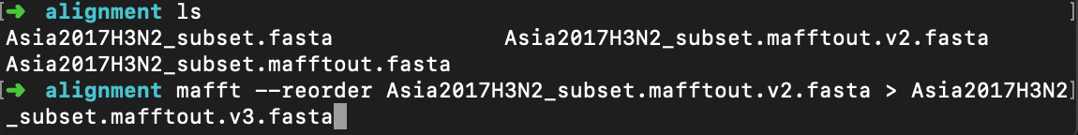

(It is important to document which version of the alignment is at each reordering and alignment edit, if there are new gaps repeat the previous steps until an optimal alignment is reached)

**Maximum Likelihood Trees (RAxML)**

Maximum likelihood (ML) method allows us to study the phylogenetic signals within a given dataset and can give us an indication about the potential temporal nature of the population over time. Here we will use the command line version of RAxML. The GUI is also available but fasta files must be converted into PHYLIP files the command line version takes both fasta and phylip files.

An example Terminal Command is seen below. (For PC users in command prompt, use path to raxmlHPC.exe instead of ./raxmlHPC , this file can be found in the WindowsExecutables when downloading RAxML) :



In the above command, we specify our input file (-s input file), our output file (-n output file), our nucleotide substitution model (-m model), a random number seed (-p #), and number of runs (-N).

The random number seed is randomly selected because the RAxML algorithm requires a degree of randomness. Additionally, the number of runs can set to optimally run until the highest likelihood tree with bootstrap support is found using the command –N autoMRE. In our tutorial, we will do three runs which should take 5-6 minutes when ran locally. For larger datasets and to preform bootstrapping runs, the use of a computing cluster is recommended.

Once the program has run we will receive several outputs:

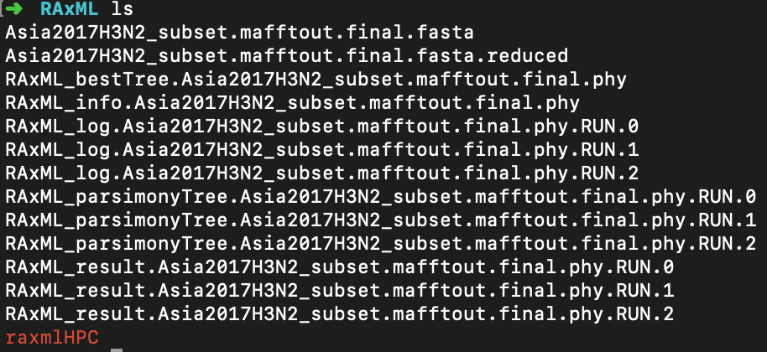

The program outputs a reduced fasta file .reduced if there are sequences that are identical within the sample, this file can be used for subsequent analysis. The program will output log files for each run as well as a parsimony tree. The RAxML bestTree file contains the tree with the best likelihood tree. For further visualization of our ML tree we will find the best root using the program TempEst.

**TempEst**

TempEst is a program that allows us to look at the temporal nature (“Clockliness”) of the tree that we created in RAxML. We will use this program to fine the best fitting root. This program will read in the sequence names and match the date given with the sequence data in order to investigate its time signal.

Using this program allows us to identify outliers that we can take out of our dataset prior to our BEAST run and can give us an idea of when the most common recent ancestor (TMRCA) of the population existed.

1. Open TempEst v1.5.3. When prompted, open the RAxML_BestTree file from our ML run.
2. Click on the Parse Date button. This will open a menu where you will choose the delimiter and input format of our data information. This is where proper labeling becomes important, using our delimiter of | we indicate that the last delimiter is where our data for date is located. The parsing of the calendar date is done by specifying the format in the label, here we use MM/dd/yy (When importing month information, it is important to use upper case M instead of lower case m, these mean two different things for the program). The program will then parse our data and output the decimal format of the date information.

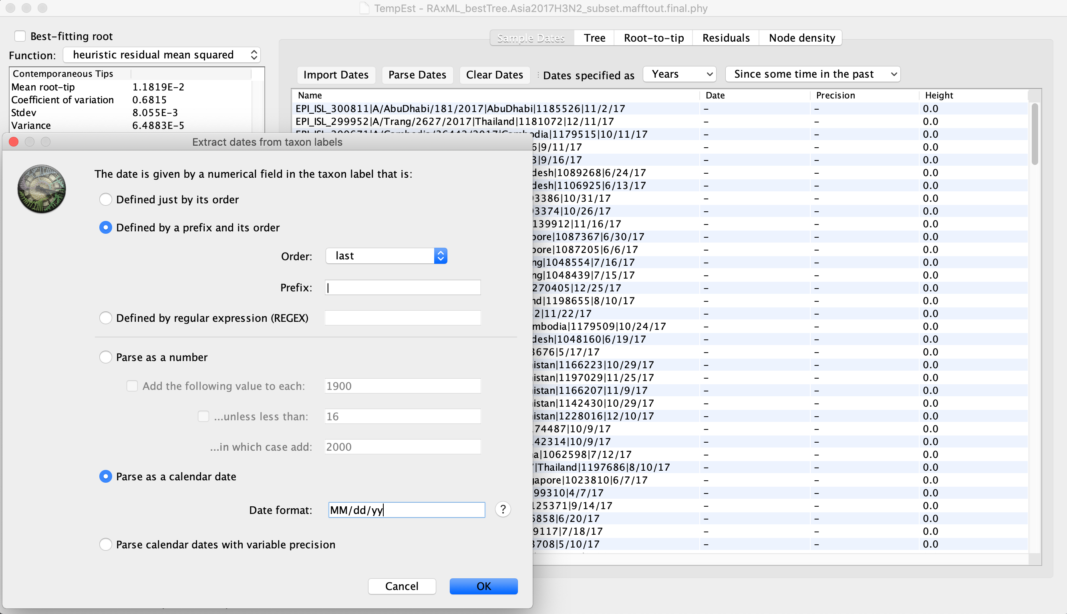

1. Click the box for Best-fitting root at the top left corner of the window. This will calculate the best fitting root and will allow us to root our tree and observe potential outliers.
2. In the tree tab, we can see our tree fit with the best root, this gives us a good view of what the data looks like, the highlighted branches are sequences that are potential outliers, in order to examine the outliers, check the Residuals tab.

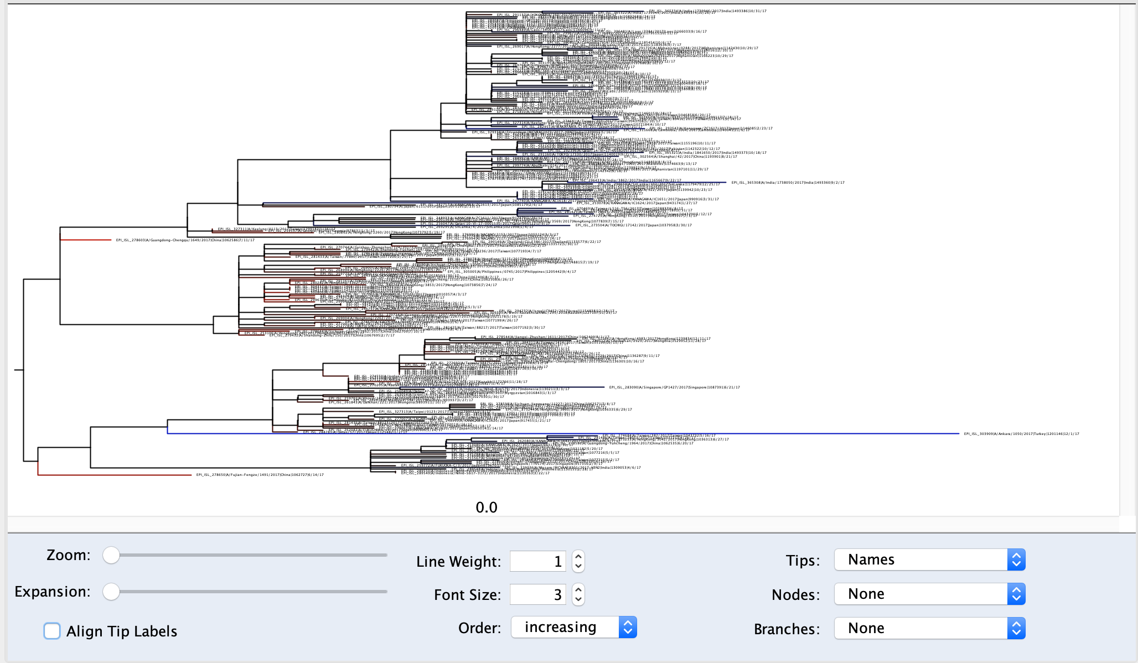

1. In the residuals tab, we see the residual distribution, the outliers can be determined by the 0.005 and 0.01 margins from the center of the distribution. In this tutorial, we will remove the outliers outside of the 0.005 margins.

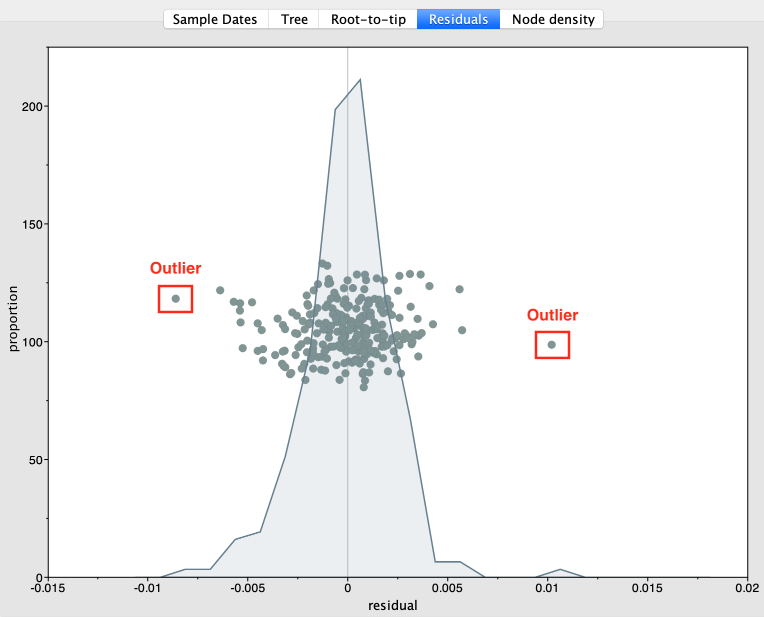

1. In the root-to-tip tab we can see the distance of each sample from the calculated root of the entire tree. The x-intercept is the estimated TMRCA (the most common recent common ancestor) of the samples in the dataset. This data can also be paired with the data in the left panel which displays the TMRCA and the variance in the samples.

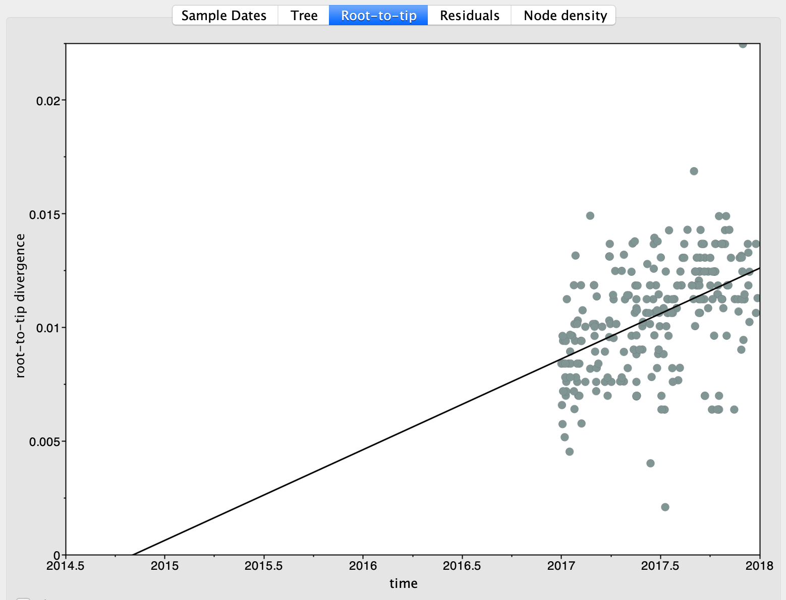

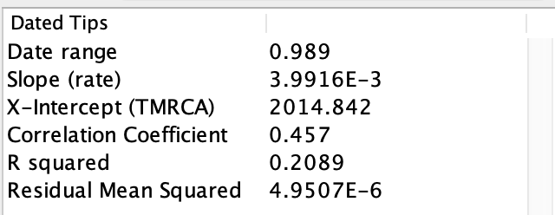

From our Tempest analysis, we can identify and remove the outliers from our tree. We can re-run the maximum likelihood tree and use our dataset without outliers for use in BEAST.

The fasta file that we create without outliers should be properly labeled in order to distinguish from our original fasta file. (ex. add .outcut to file name (outliers cut))

**Phylogenetic Diversity Analyzer (PDA)**

The Phylogenetic Diversity Analyzer (PDA) uses a clustering method to determine the best phylogenetic grouping from a given tree. There is a command line tool as well as a web portal. We will use the web portal found here: <http://www.cibiv.at/software/pda/web-pda/>. Upload your tree file to the portal and click “run”.

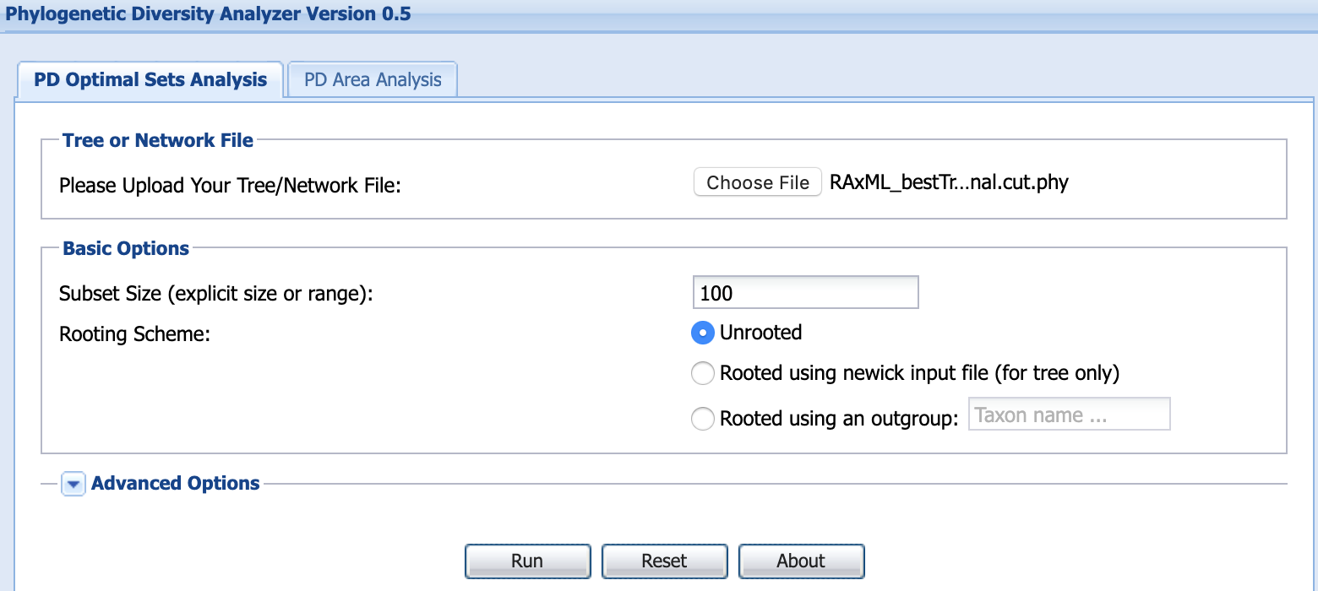

The output will be a list of sequence labels that correspond to the best subset of specified length. Copy and paste these labels into a text file.

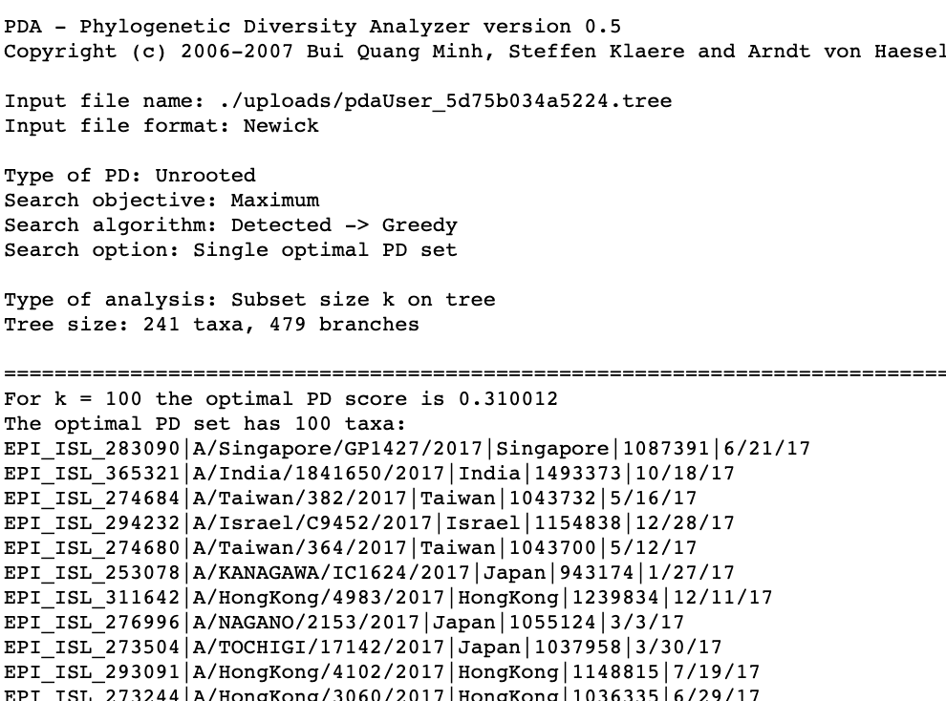

Using the following command you can use the text file with sequence labels to extract a smaller fasta file with our desired sequences from our original fasta file:

grep -A1 -w -f id.txt input.fasta > output.fasta



**BEAST- Setting up XML**

In order to run BEAST locally on your own machine you must first create an XML file which contains the sequence data and parameters for your BEAST run. This XML is created using BEAUti.

1. Open BEAUti v.1.10
2. Drag your fasta file into the window with the Partition tab.
3. Navigate to the Tips tab and parse tip dates using same method used in TempEst.

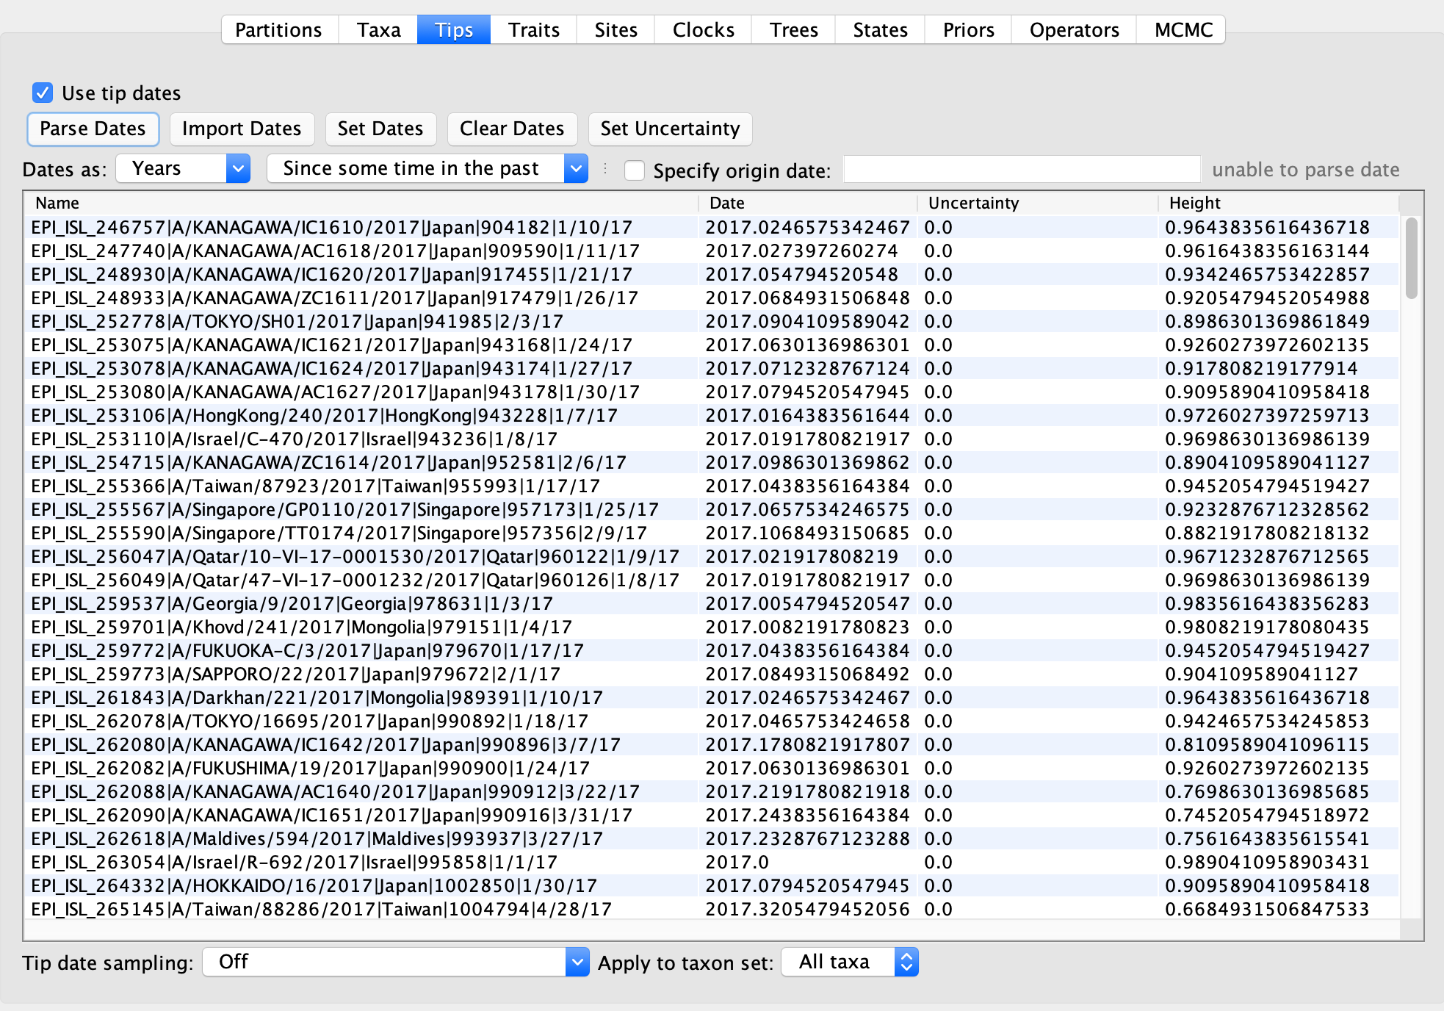

1. In the sites tab, choose your nucleotide substitution model. In this tutorial, we will use the same model used in our RAxML run: Generalized Time Reversible with Gamma distributed sites (GTR Gamma). The nucleotide sub model that you choose is dependent on the organisms being studied and your available data.

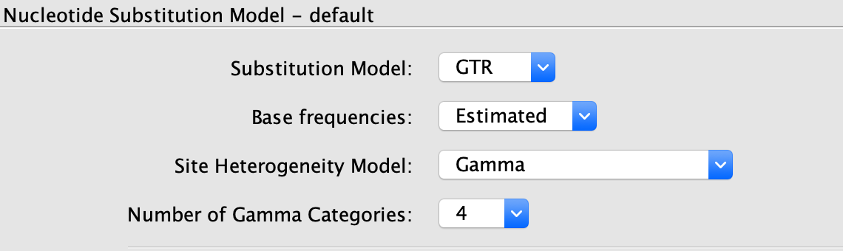

1. In the Clocks tab, choose your clock model. This is determined based on the clockliness seen in TempEst.

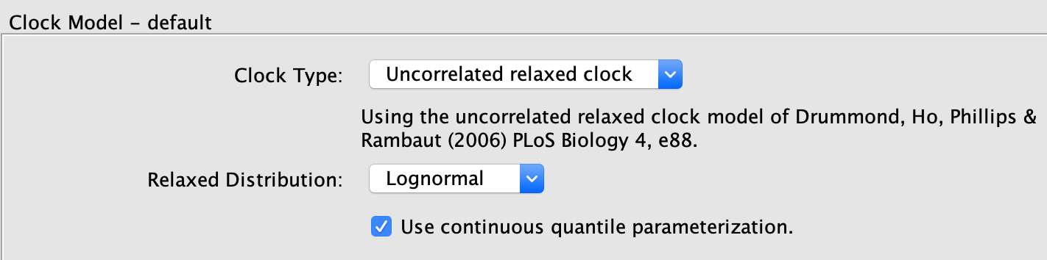

1. In the Trees tab, choose your coalescent – here we are using a GMRF skyride coalescent. Your Coalescent choice is typically informed by available population data.

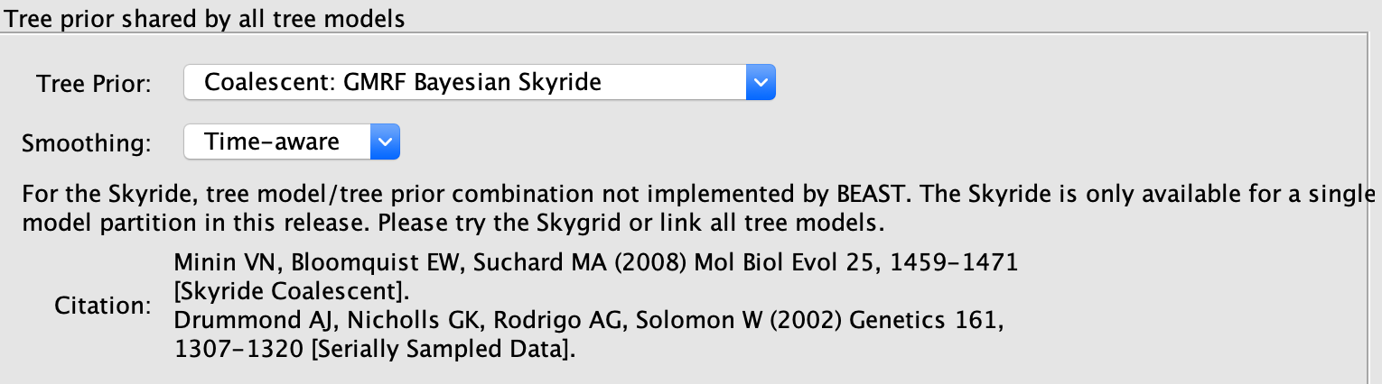

1. In the Priors tab, we can provide our BEAST run with prior data for different parameters if we have relevant data. Here we will change the Ucld mean to uniform, using the values seen below.

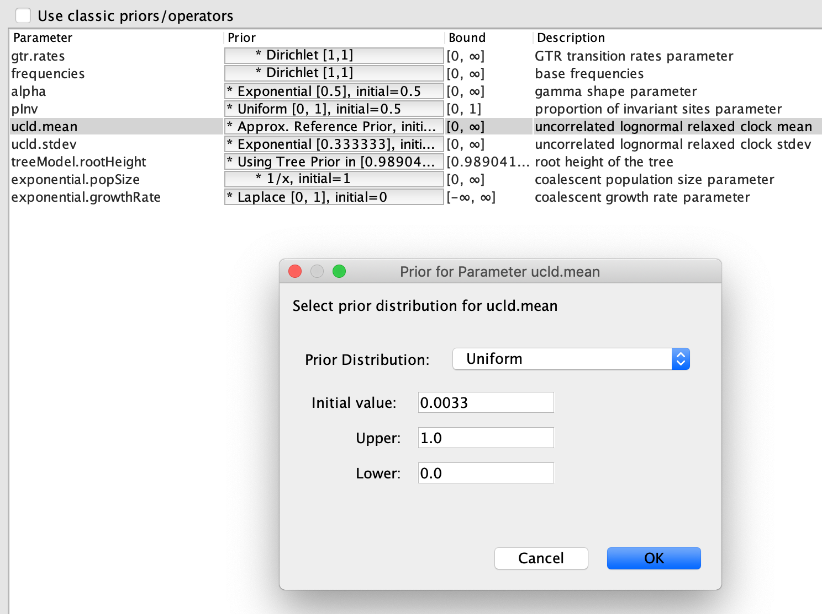

1. Set your MCMC chain length and generate XML file.

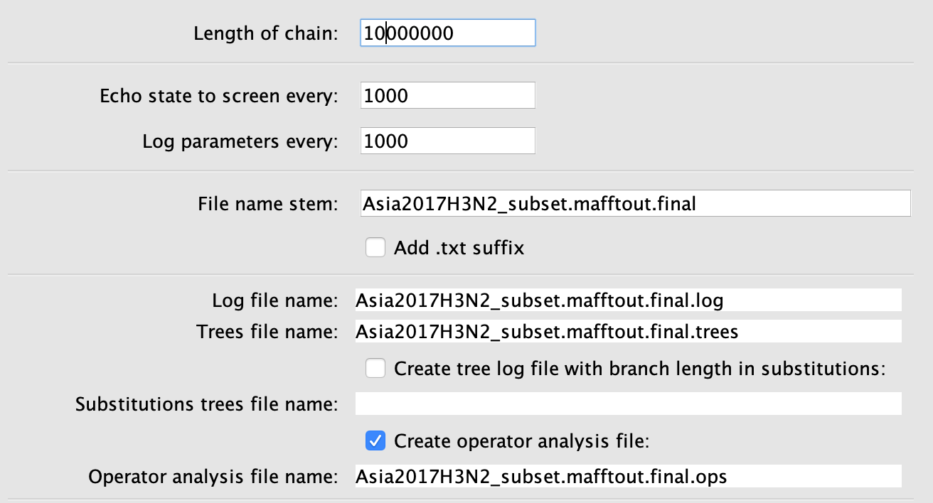

**Running BEAST**

Typically, you should do several runs (3-6) of BEAST. This is because of the potential for the MCMC to not converge on the optimal tree if a run is not optimal. Additionally, these runs can be added together and the trees sampled for a greater tree likelihood.

1. Open BEAST v1.10
2. Drag your XML file for BEAST run into the program.
3. Run program. While running the chain length will be displayed as well as the rate of calculation. This can give you an indication of how long your run will take depending on how long your chain is.

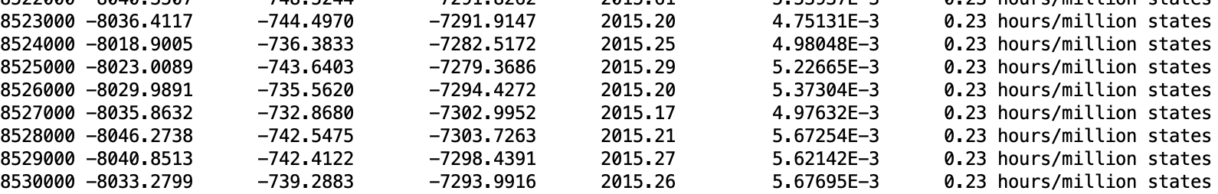

Once your run is completed save the results in a separate folder from your next run. Keeping multiple run folders with a copy of your XML file will prevent accidental overwriting of a previous runs data. There is a command line version of BEAST that can be implemented in computing clusters and locally, examples can be found on the linked BEAST community page.

In this tutorial, the original dataset of ~250 sequences do not converge with a 10 million length MCMC (results seen below labeled as “bad run”). With larger datasets, a longer MCMC is needed to converge (100 million chain length, sampling every 10000 states would have been more appropriate but the computation time would take a day at the least. In order to show results for a smaller dataset that would run in a reasonable amount of time the data will be sample down further from ~250 samples to 100 samples. We will use a phylogenetic method to sample down (Phylogenetic Diversity Analyzer) which can be done post-RAxML (or other tree building methods e.g Neighbor Joining method PUAP) as opposed to random sampling to give phylogenetic significance to our sampling.

**Analyzing BEAST results**

1. Open **Tracer v1.7.1**.
2. Drag .log files from each of the BEAST runs results folder into Tracer.
3. Examine the ESS (Effective sampling scores) scores. The ESS score is a measure of the posterior probability distributions that occur on the Markov Chain. Smaller ESS values are indicative of poor posterior distributions for given parameter. A good threshold is ESS > 200.

Below is an example of combined runs from 3 “good” runs. In each of the runs the column labeled ESS had no values under 200. Be aware that if there are values that are less than 200 for one run but not for the others, this can result in a combined run that is greater than 200. This is why doing multiple runs is important, when examining the trace, you can see that there will be runs that do not converge on the optimal tree while others do.

Good run:

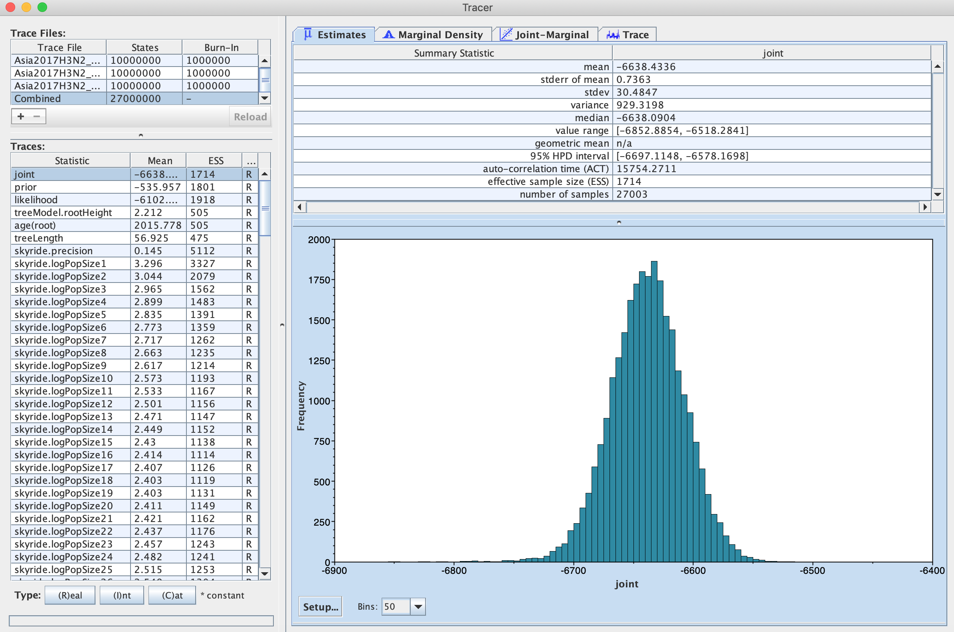

In the bad run below you can see that there are several values that do not have a high enough ESS score which indicates a poor posterior probability. Ways to deal with this include increasing the burn-in, or running a longer chain length of your MCMC.

Bad run:

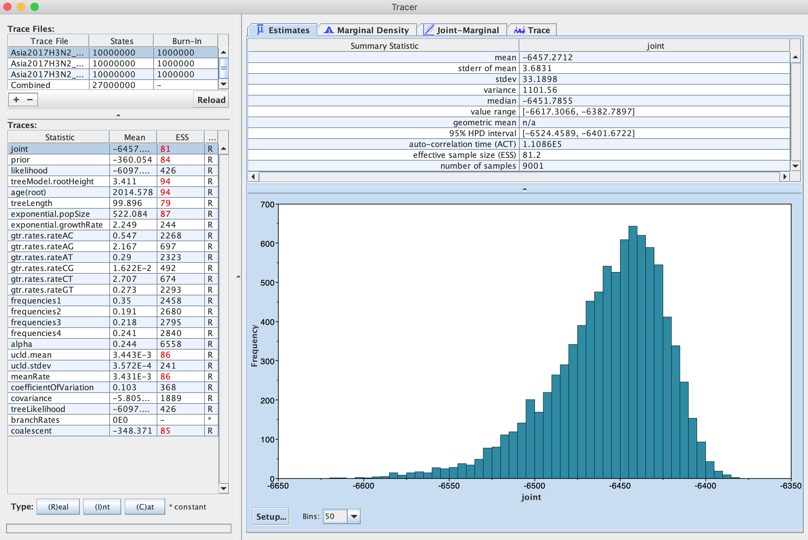

1. Examine the trace of the MCMC to determine if your chain has converged.

The length of your MCMC chain is very important especially for larger datasets. At each link in the chain the BEAST algorithm is changing parameters and calculating the probability that a given tree at one point in the chain is the optimal tree for the given parameters. During the initial phase of the MCMC there is a burn-in where the chain is continually changing in order to find the best probability. Once the algorithm starts to converge upon an optimal tree the chain will remain within a certain region. For larger datasets or datasets that have trouble converging, a longer chain length is used to give the algorithm more time to get past burn-in.

Good run Trace:

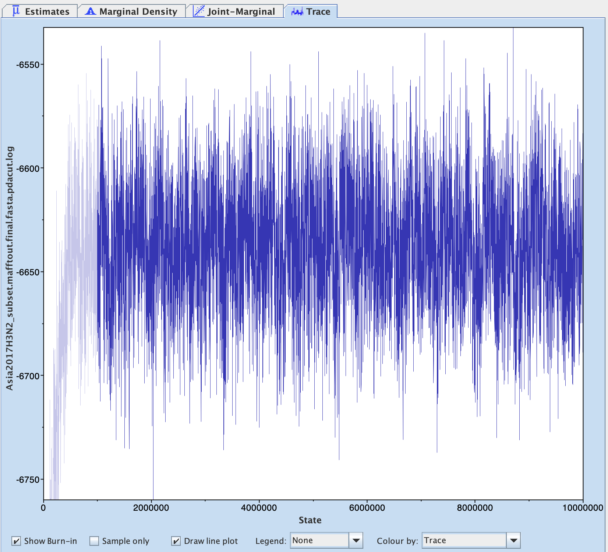

In the good run Trace above the burn-in is grey, and the chain seems to converge. As you might notice there are several jumps that occur and this is because the algorithm is continually resampling and changing parameters in order to find the optimal tree until the specified chain length has been met. In the bad run Trace below you can see an erratic chain that has not converged.

Bad run Trace:

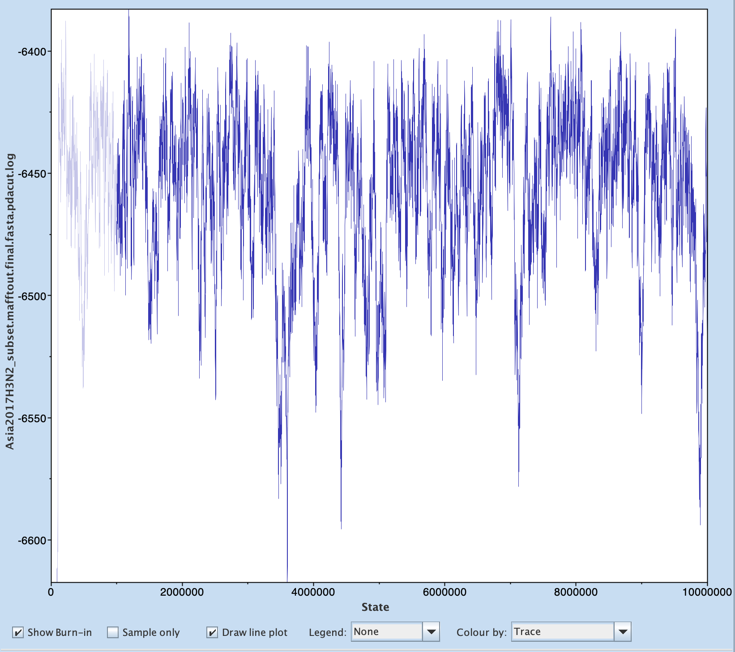

1. **Using LogCombiner v1.10** We will use the burn-in for each run to combine the tree files into a sampled tree file. Choose the tree file type. Output file should be similarly named, add .combined to ensure proper documentation.

The resampling frequency is calculated by dividing the remaining combined chain length after burn-in by the number of desired trees (It must provide an integer result; decimal values will not be accepted)

For 9000 trees: 27000000 / 9000 = 3000

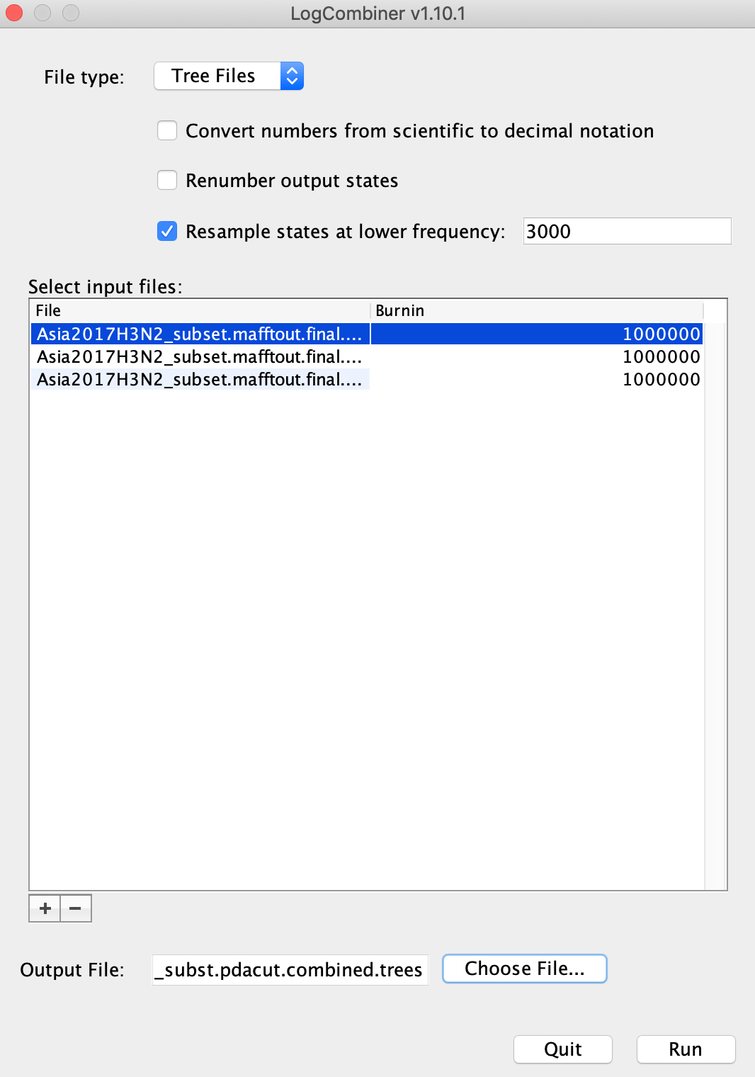

1. Using the combined tree file with 9000 -10,000 trees we will create a consensus tree using **TreeAnnotator v1.10**. We will set the annotator to only annotate nodes that have a 95% probability HPD.

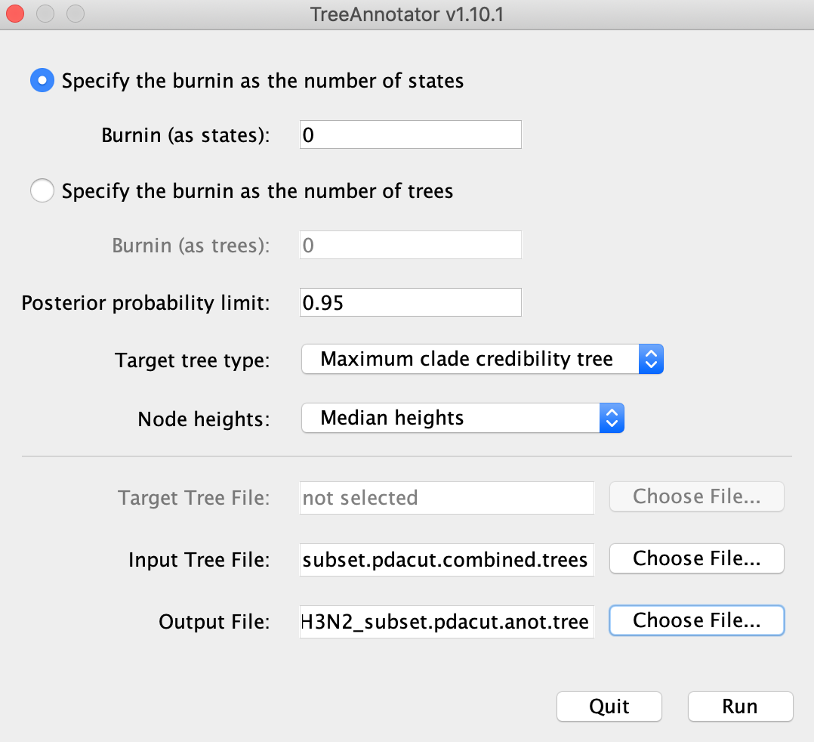

When creating the consensus tree ensure proper documentation in the name of the final file, here we use .anot in the file name to indicate that it is an annotated tree file. The output file should also be changed from .trees to .tree because there will be only one tree.

**Visualizing BEAST trees**

We can view our annotated tree using the program FigTree.

1. Open annotated .tree file in FigTree.
2. Click the dropdown menu “Trees” and click the Order nodes box and select increasing.

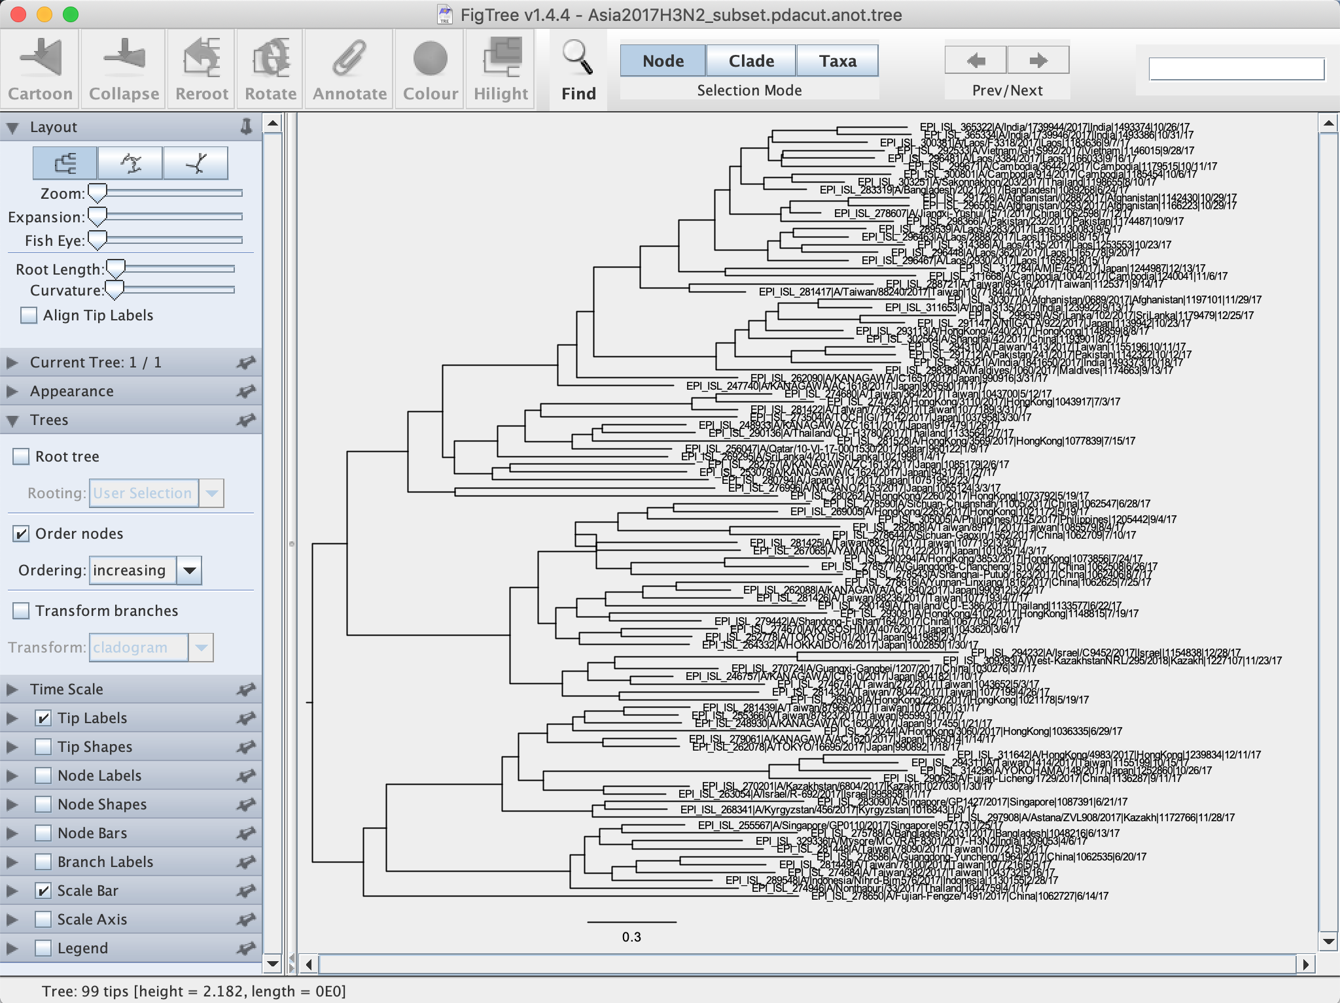

1. In order to create a time scale choose the Time Scale tab and in the offset value enter the **most recent** sequence collected, in this dataset it will be 12/28/2017. The decimal value should be used and can be retrieved from BEAUti.

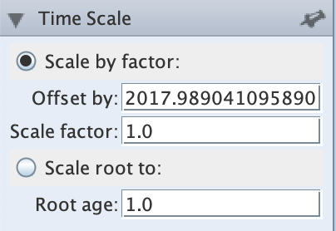

1. Select the Scale axis tab and click reverse axis. This will create a time scale at the bottom of the tree.

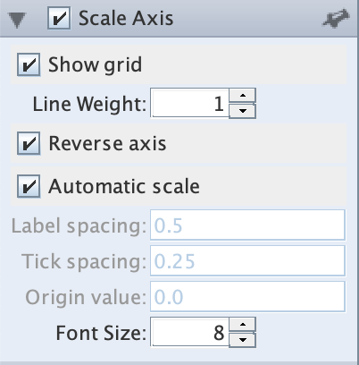

1. Node labels and bars can be added to show the posterior probability of a node and a given distribution of that that probability with the nodes at 95% HPD. This can be done by clicking the boxes below.

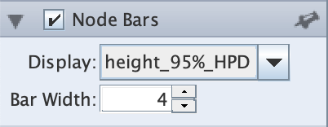 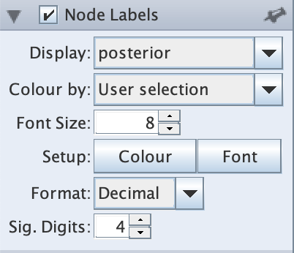

1. The final tree can be exported to PDF or other formats. Color highlighting of nodes, labels and clades can be done in FigTree.

Untitled.pdf